Project Design Phase
Solution Architecture
Date | 20 July 2026
Team ID | FinWise AI Team (SmartBridge SIP 2026 - SRM AP)
Project Name | FinWise AI - Intelligent Loan Eligibility, Credit Analysis & Financial Advisory Platform
Maximum Marks | 4 Marks

Solution Architecture Diagram
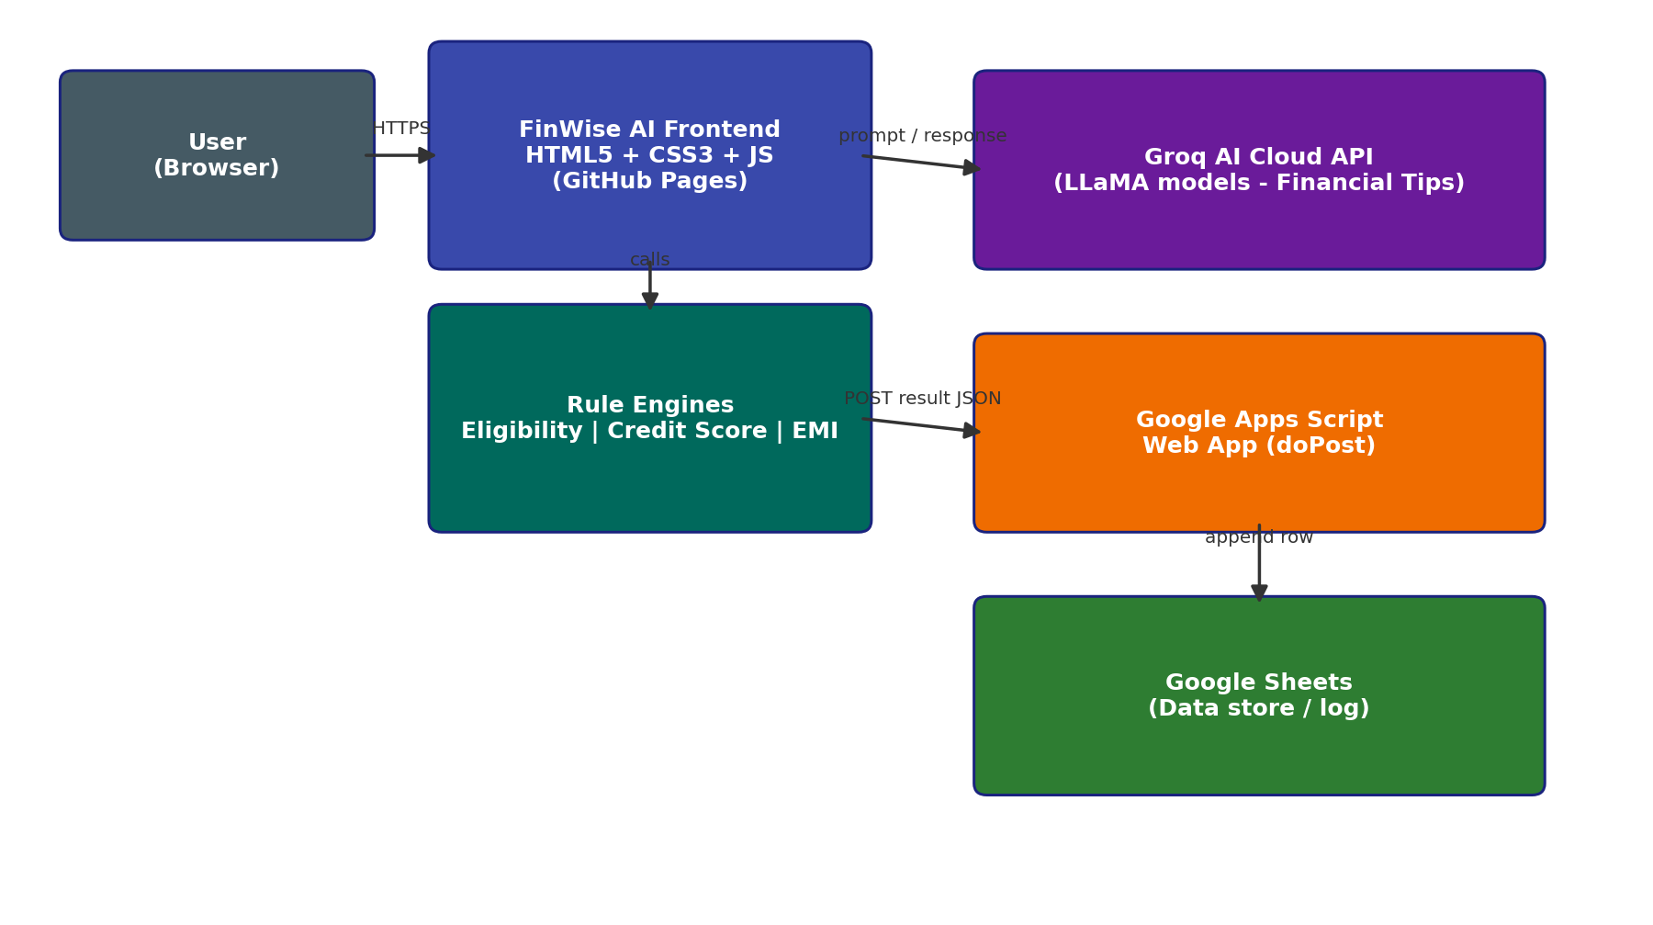
Figure 1: FinWise AI solution architecture - static frontend calling Groq AI and a Google Apps Script + Sheets backend.

Architecture Description
Layer | Description
Presentation Layer | index.html, eligibility.html, credit-score.html, emi.html, tips.html - built with HTML5, CSS3 (glassmorphism theme) and vanilla JavaScript; hosted on GitHub Pages.
Application / Logic Layer | Client-side JavaScript modules (app.js, eligibility.js, credit-score.js, emi.js, tips.js) implement the rule engines for eligibility, credit classification and EMI, and orchestrate calls to the Groq AI API.
AI Services Layer | Groq AI Chat Completions API (LLaMA-family models) receives the user's financial inputs as a prompt and returns personalised financial guidance in real time.
Data / Integration Layer | A Google Apps Script Web App exposes a doPost endpoint; the frontend POSTs each result as JSON, and the script appends it as a row in a linked Google Sheet, acting as a lightweight, serverless data store.
Deployment | The entire frontend is static and deployed via GitHub Pages, requiring no application server; Groq and Apps Script are called directly from the browser over HTTPS.

